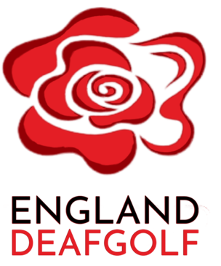
Treasurer’s Report
2024
- SUMMARY
Total income was £18,219, down from £43,153 in 2023. This year saw decreased raffles due to time commitments by those running the raffles. This is planned to resume in 2025 with improved structure and incentives. We also saw reduced Sign Video commission from £9,538 to £4,081. Efforts are being made to improve this source of funding (see section 7).

Total costs of generating funds were £17,307, against £34,703 in 2023. This was again an impact of the raffles, but also funding given for international events (see section 9). We also invested £1,722 in equipment to help boost our social media activity (see section 8).

Administrative expenses were £631, down from £865 in 2023. This was driven by reduced number of Google accounts for committee members, and reduced membership fees to WDGF, UKDS and England Golf.

Net surplus was £280 against £7,585 in 2023. We currently have accumulated a surplus of £16,695 to be used for our charitable purposes (see section 10).

Our net profit from events was £397 against 2023 of £1,025. In 2023 one of our events was subsidised by the Golf Club which distorts the picture slightly (see section 5), and we have invested in Stripe as a payment method (see section 4). We continue to use these profits to subsidise GolfBox for the benefit of our societies (see section 6). We also saw a net loss on Raffles, which was due to timing of a raffle which crossed over our 31 December 2023 year end.

On the balance sheet, we have reduced accrued income from SignVideo partnership, and our cash balance has dropped year on year due to paying deposits for our 2025 events. We also have £500 of prepaid costs in respect of Golfbox (see section 6). Deposits from players have dropped as the 2023 position was deposits received for the 2024 World Deaf Golf Championships.

We remain in a strong financial position which is necessary to minimise risk to the organisation of being unable to pay deposits for events or being unable to fund charitable activities which have focussed on future development of juniors, young adults, and increasing participation in Deaf Golf (see section 10). We also require a surplus to cover any eventualities from the WDGC 2028, and the EDGC 2027.

I also give thanks to outgoing assistant treasurer Matthew Monkman, for all his hard work maintaining the accounts, processing payments, and operating as an independent reviewer of transactions to ensure we maintain a strong controls environment.

- STATEMENT OF FINANCIAL ACTIVITIES

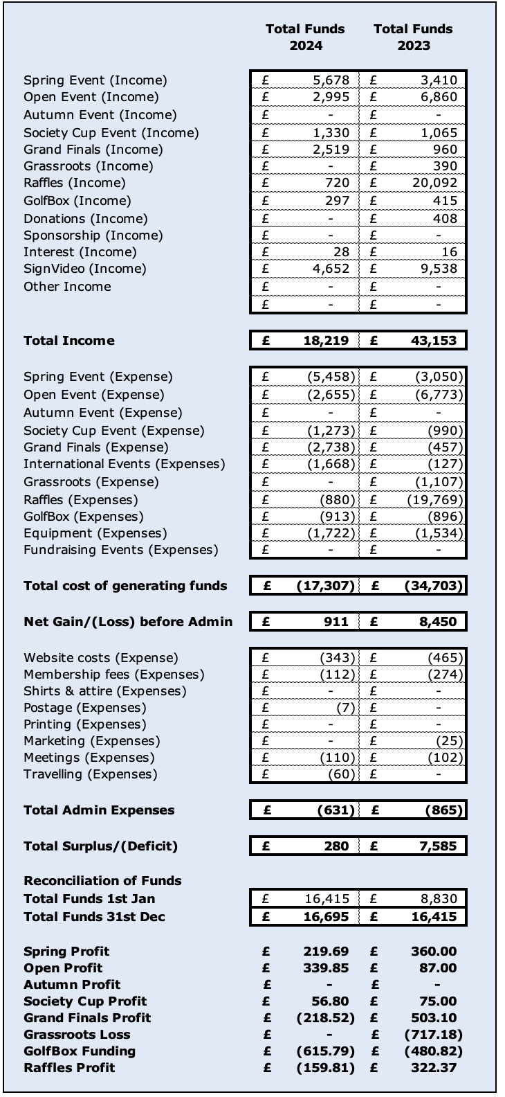

- STATEMENT OF FINANCIAL POSITION

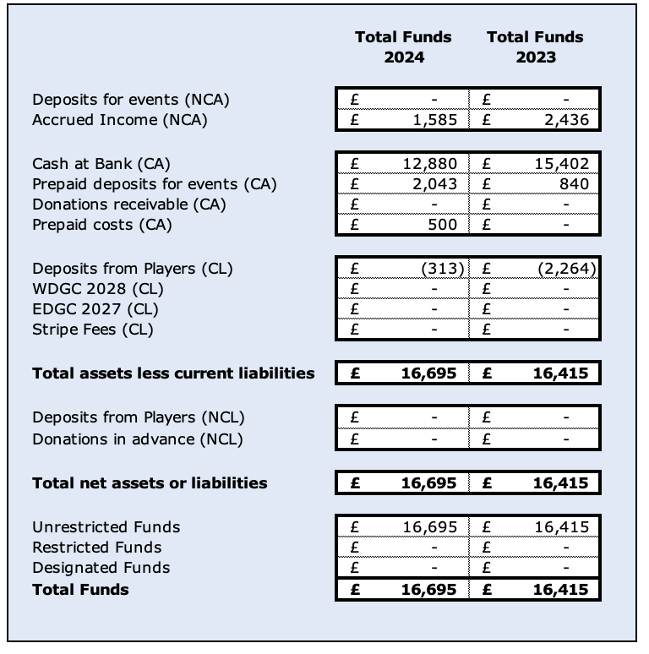

- STRIPE
This season saw the successful introduction of Stripe into our GolfBox software. This function allowed golfers to pay using debit/credit card in full for our events when entering on GolfBox, with entry only permitted into the event once payment is made.

Stripe charges a 1.3% transaction fee against the event costs. This was deemed necessary to reduce committee time chasing for outstanding payments, but also to protect against late withdrawal by players who have paid deposit, but not paid in full before the deadline set by the golf club for final numbers. In the 2023 year we saw reduced profit in the Open for this reason where golfers pulled out after we had committed to their attendance at Close House, having only paid deposits.

We continue to offer this functionality also to our societies. One society (K2) used this successfully with payment made to EDG, which was transferred to the society before the deadline set by the golf club hosting their event. We encourage our Societies to take up on Stripe payments.

- EVENTS
This year we held 4 events. The Spring Event was held at Frilford Heath (Oxford), The Open Championship was held at Westerham (Kent), The Team Society Cup was held at West Midlands (Birmingham), and the Grand Finals was held at The Nottinghamshire (Championship).
We made the decision to part-subsidise the Grand Finals with the income from our Spring, Open and Team Society event, and reduce costs for members whilst increasing the prizes on offer, along with trophies for the winners.

Event | Golfers 2024 | Golfers 2023
Spring Event | 24 | 33
Open Championship | 20 | 23
Team Society Cup | 35 | 30
Grand Finals | 36 | 28

We saw improved participation in the second season of the Grand Finals, as societies and golfers continued to improve awareness of the event which crowns the winner of the whole season in a format similar to the Fed-Ex Cup on the PGA Tour. We remain committed to this format with a minor tweak incoming for 2025 to move this to a Net format, and award Gross prizes. This will continue to be held in a central UK location.
Our Team Society Cup (Kevin Whalley Shield) continues to boast strong numbers, and we are committed to holding this event in the central location of Birmingham for the foreseeable future.
The Spring Event saw reduced numbers with the poor weather to start the year impacting on reduced desire for golfers to play. The second day was rained off after 9 holes, but we thank Frilford Heath for their hospitality, including moving us onto the superior Red course for the second day to allow us to make the most of the inclement conditions.
The Open Championship saw reduced numbers due to a mistaken clash with the Nottingham Deaf Society Open Event, and golfers saving funds for the World Deaf Golf Championships 2025. We have placed measures to prevent this from happening again, with all societies requiring letting us know when their fixtures are so that we can book events and not clash with our Societies. All fixtures for 2025 can now be found on our Website on GolfBox.
- GOLFBOX
We have entered into a 5-year agreement with GolfBox following the success of our events and societies using the software. This reduces our cost from €1,500 to €1,000 per year.
Along with GolfBox we stipulate that only golfers with iGolf or Club Membership can participate in EDG or Society events, to ensure they have a valid handicap to protect the integrity of the event. At the time of writing we have a member database of 201 golfers, of which 105 golfers are members of iGolf, which is fantastic to help legitimise our Deaf Golf Societies.
To help recover the costs, we charge a small uplift in entry costs to our events, and Societies are charged £10 per round that they use the software for. This is performed at a loss of £616 in 2024, and 2023 of £480. However this continues to represent our commitment of support to all of the England Deaf Golf Societies. We give thanks to the below societies who have embraced iGolf and GolfBox and continue to work with them to build participation:
- Birmingham Deaf Golf Society
- K2 (Kent) Deaf Golf Society
- Leicester Deaf Golf Society
- North Deaf Golf Society
- Nottingham Deaf Golf Society
- Saxon Deaf Golf Society
- South Deaf Golf Association
- Teeside Deaf Golf Society
- Yorkshire Deaf Golf Society

- SIGNVIDEO
We have an agent commission agreement with SignVideo. This means we receive a small percentage of commission that individuals receive from signing up to SignVideo through Access To Work, using our referral code.
We have seen a year on year drop off in commission due to the retirement of 2 individuals who signed up on the scheme, and we ask all golfers who are looking for virtual BSL interpreters to use SignVideo.
For the 2025 season we have taken steps towards Rod Oaten being the primary contact for all those wishing to use SignVideo, please contact him for advice and support as all funds obtained are crucial to funding our charitable objectives.
- EQUIPMENT USAGE
This season we took the decision to acquire Drone and Video Recording equipment to be used to improve the publicity our events generate, and help drive engagement on social media.
To this end we started up a YouTube Channel and uploaded footage from the Spring Event, Open Championship, Grand Finals, and Training Camp. The Spring Event and Grand Finals captured various footage of golfers and the winners. The Open footage followed the winner of the event and the Seniors winner around the course to help show what the event is like for those wishing to attend, but also share awareness of Deaf Golf.
We have seen positive effects from this investment with the YouTube videos capturing 1,200 views, with traffic on our website growing by 1,300 clicks in 2024. We will continue to build and share footage of all our events, and any support with videos/filming would be greatly appreciated.
- INTERNATIONAL EVENTS
2025 saw the World Deaf Golf Championships held in Australia. All players deposits and entry fees were paid to EDG who then paid the Championships team. We retained c.£80 per player after paying the fees which was used to pay for specialist yardage books, and practice rounds.
We give huge thanks to player John Lange who received £1,500 of donations and kindly passed this to EDG which was used to fund practice rounds and range balls for the team.
The Committee also gathered feedback from England golfers at the 2022 World Deaf Golf Championships. The main feedback from golfers was for a Team Manager to help them during the event, ensuring they have supplies, support, and coordination to enable them to perform their best without extra worries. The decision was made for Rod Oaten to become team manager and he received a donation of £2,000 towards his flight and event costs which were around £4,000.
The team performed admirably under Rods guidance, chief amongst which was his co-ordination of the Ladies teams. Upon arrival, the 2 ladies Donna Serridge-Cross and Lydia Ingman, were deemed ineligible for the Ladies Team Championship which required 3 ladies. In the Super Seniors were 2 ladies Fiona Brookes and Sue Matthews. Rod managed discussions after which Fiona joined the Ladies Team to make 3 golfers, and Sue remained in the Super-Seniors. This had a positive effect on the performance, with the Ladies team coming 3rd Overall, and Sue Matthews capturing the Super-Seniors Championship!
We thank Rod for his help and commitment during the championships and it is no surprise he won Coach of the Year at the 2024 Deaf Sports Personality of the Year.

- FUND SURPLUS
As seen above, EDG end the year with a surplus of £16,695. These funds have been built up following a decision I made with the support of the committee at the start of the 2023 that we would only use our funds for activities which either:
  - Advance the Charitable Aims of England Deaf Golf
  - Contribute positive ROI for England Deaf Golf
  - Secure the future of England Deaf Golf
  - Exercise sound financial management to ensure it can meet future obligations
Towards the end of the 2024 season, we have brought in additional committee members who have specific remits towards Grassroots event (children/juniors/newbies), Development Events (Performance Programme/Outreach), and Internet/Social Media activities. The funds which remain in our accounts will be available drive those initiatives, which should safeguard our future through:
- Finding and recruiting society golfers
- Finding and recruiting performance golfers
- Providing programmes for children to get into golf
- Providing programmes for young adults to get into golf
- Providing programmes for adults to get into golf
- Providing programmes for ladies to get into golf
- Increasing the number of Grassroots events to encourage the next generation
- Exhibitions to spread awareness of Deaf Golf
- Marketing campaigns to spread awareness of Deaf Golf
We continue to see positive returns as these activities continue to ramp up. We have a strong pipeline of events in 2025 to build on the back of a positive 2024.
- FUTURE DEVELOPMENTS
We continue to focus on bringing EDG up to Tier 1 Governance, which will enable EDG to obtain increased funding and grant opportunities. Tier 1 sports governance refers to the highest standard of governance applied to sports organizations outlined by Sport England. Tier 1 governance is typically aimed at organizations that receive substantial public funding or have a significant impact on national sports development. It sets out strict requirements to ensure transparency, accountability, and ethical management.
To this aim we are taking steps to improve financial controls, and transparency in the reporting of results which is contained within this report, and continue to follow the Charities Statement of Recommended Practice (SORP), which governs charity financial reporting in the UK whenever possible.
We continue to consider the cost/benefit of turning England Deaf Golf into a registered charity, which brings with it increased regulatory and organisation requirements. As of now there are no concrete plans to become a Charity, but it remains a key consideration for the Committee in the future.
- AUTHORISATION
Matthew Bradshaw
Treasurer for England Deaf Golf

